INDIA’S AGRICULTURE CROP PRODUCTION ANALYSIS (1997-2021)

BACHELOR OF SCIENCE

IN

MATHEMATICS

BY

D.AVILA

V.SATHISHKUMAR

SMS College of Arts and Science

Kallamanaickerpatti

(Affiliated to Madurai Kamaraj University)

**INDIA’S AGRICULTURAL CROP PRODUCTION ANALYSIS(1997-2021)**

SYNOPSIS

* Introduction
* Empathy Map
* Brain Storming
* Dash Board
* Story
* Project Result
* Project Advantage
* Project Disadvantage

Introduction:

**This report delivers into the captivating real of India’s agricultural cultivation, providing a comprehensive visual exploration of key aspects and trends in the agricultural sector. Through the visual representations, readers can gain valuable insights into crop production, seasonal variations, regional distribution and overall production trends. These visualizations enable intuitive analysis, allowing stakeholders to uncover patters, identify areas of growth or concern and make data-driven decisions.**

**By harnessing the power of Table this report not only presents the data in a visually appealing manner but also provides an interactive experience for readers to explore the intricacies of India’s agricultural cultivation. To extract the insights from the data and put the data in the form of visualizations Dashboards and Story we employed Table tool.**

**Problem Definition &Design Thinking:**

EmpathyMap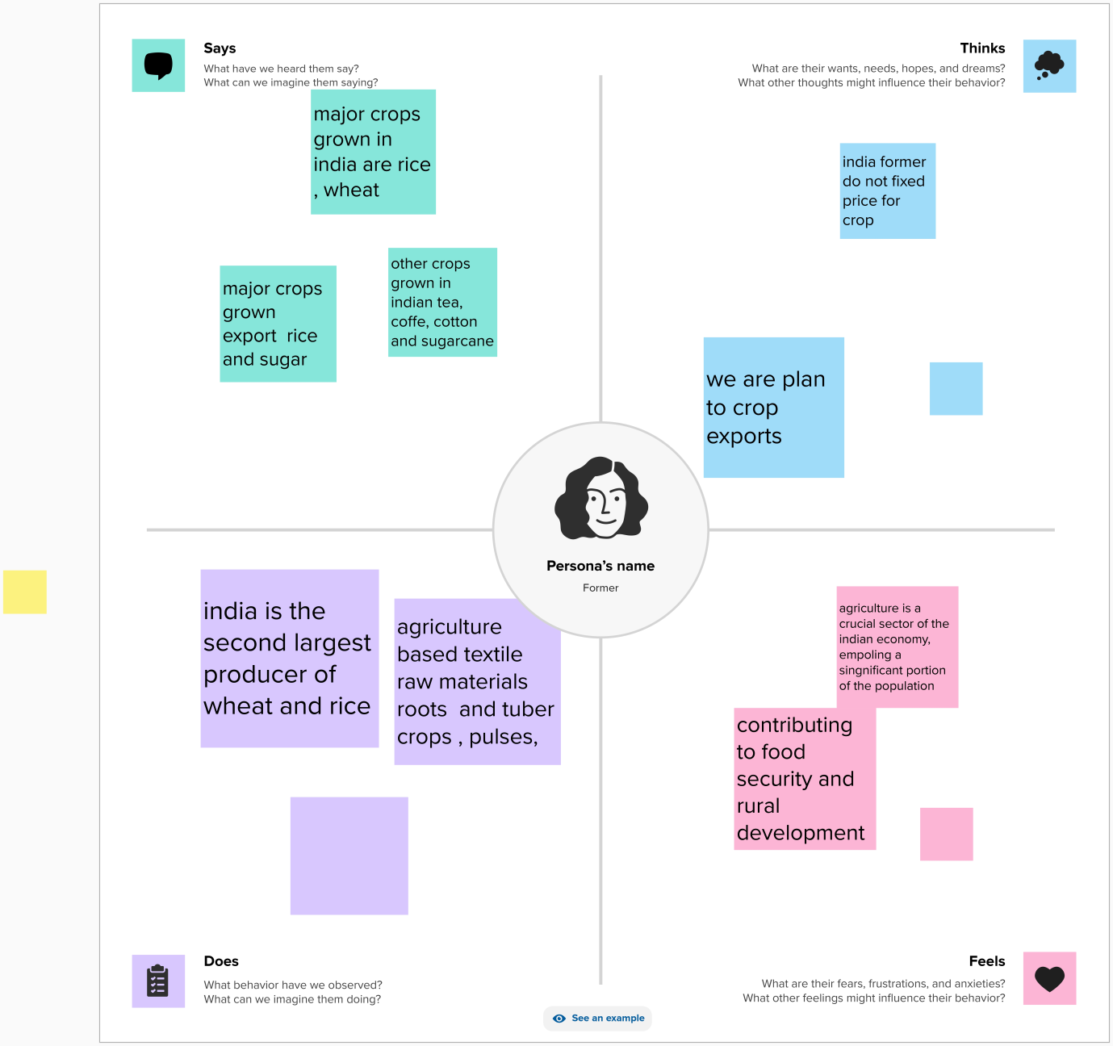

Ideation & Brainstorming Map

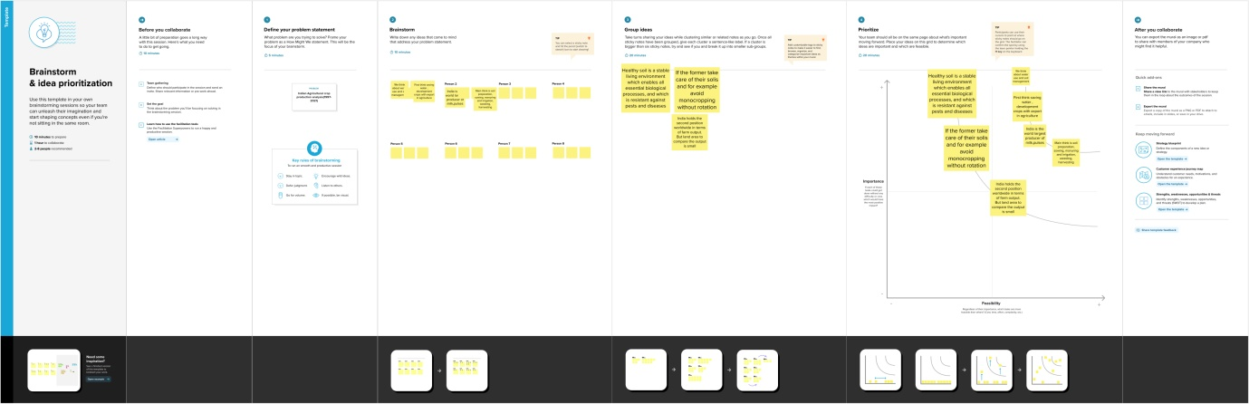

Dashboard:

A dashboard is a graphical user interface that displays the information and data in an organised, easy-to-read format. Dashboards are often used to provide real-time monitoring and analysis of data and are typically designed for a specific purpose or use case. Dashboards can be used in variety of settings, such as business, finance, manufacturing, healthcare, and many other industries .They can be used to track key performance indicators, monitor performance metrics, and display data in the form of charts, graphs, and tables

Dashboard 1

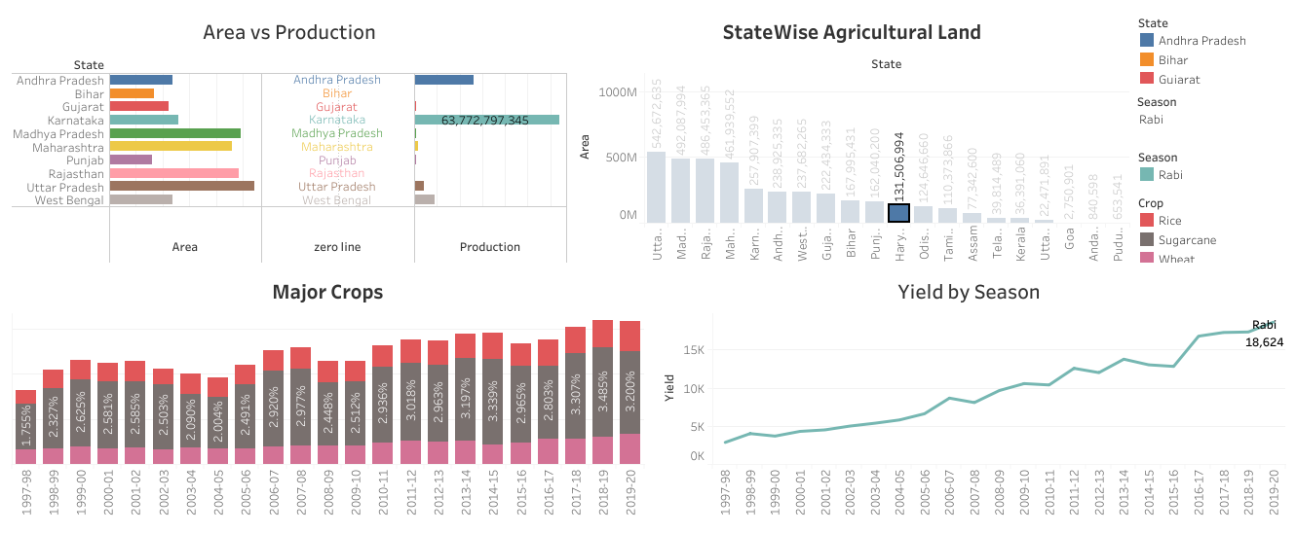

Dashboard 2

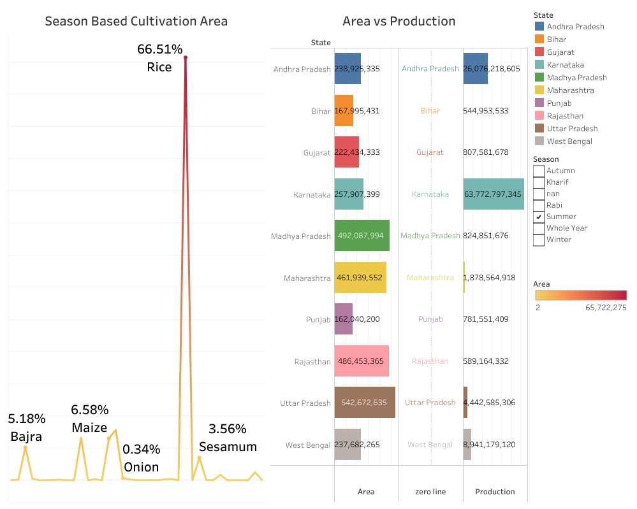

Dashboard 3

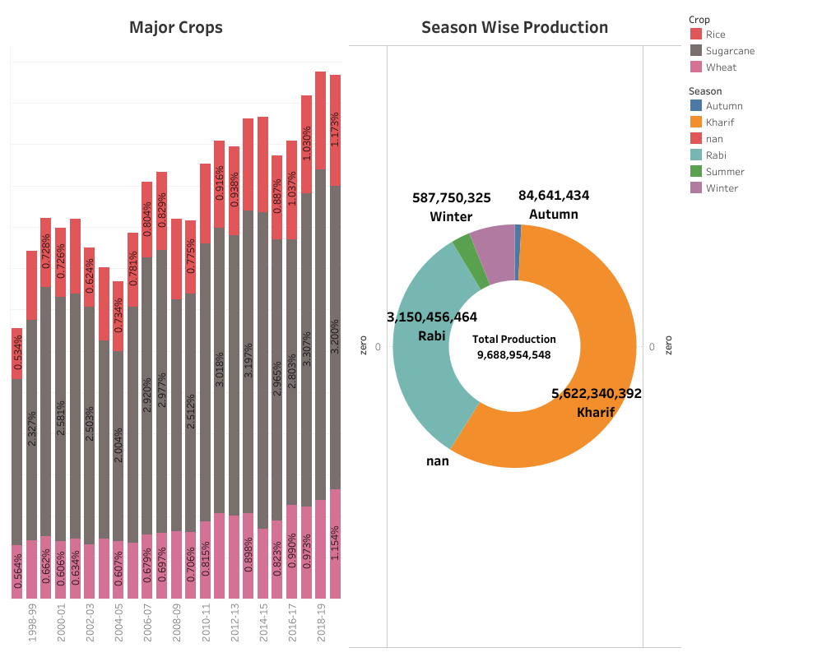

Dashboard 4

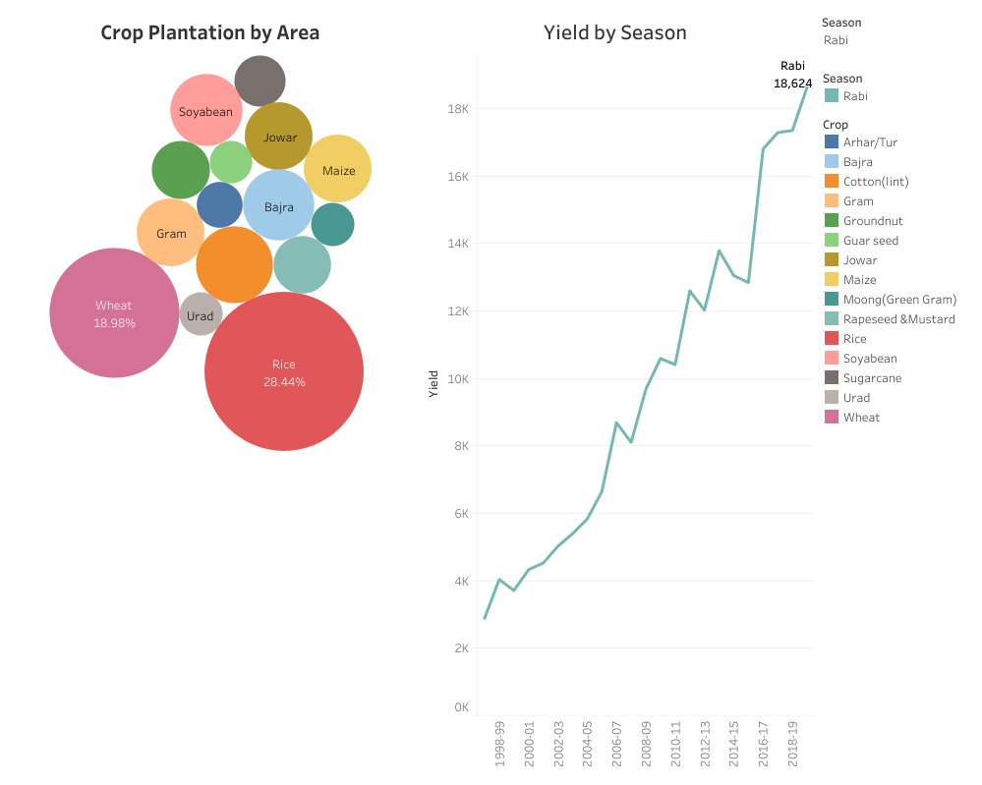

Stories

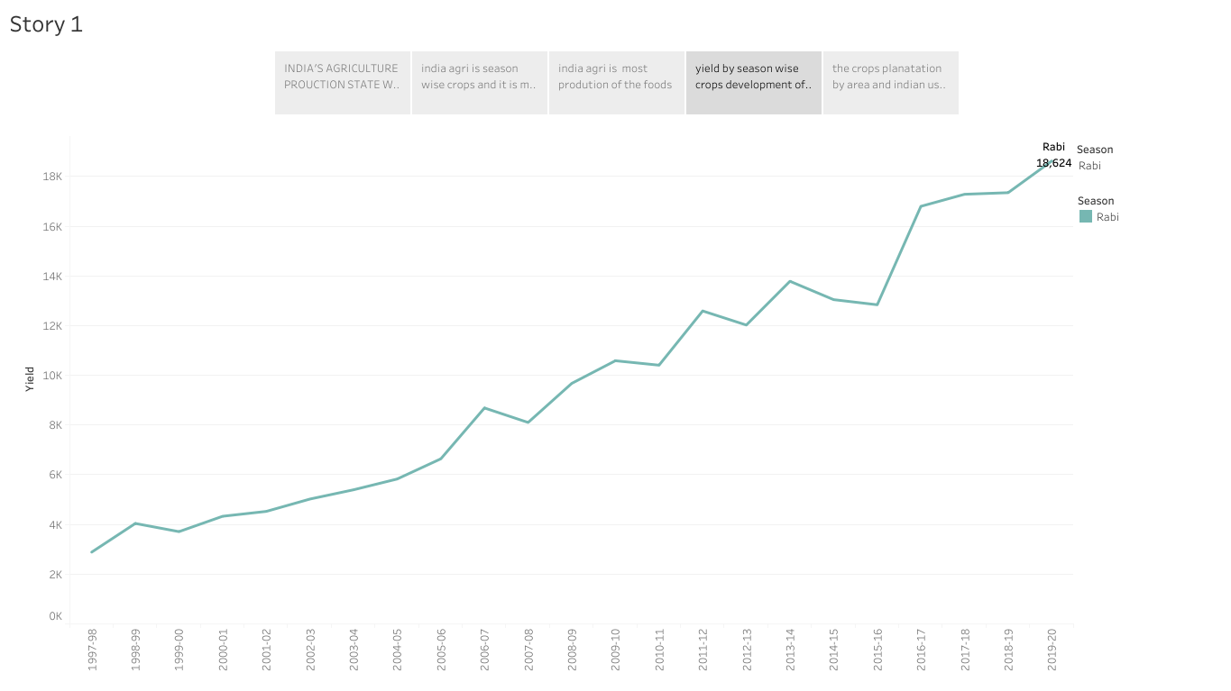

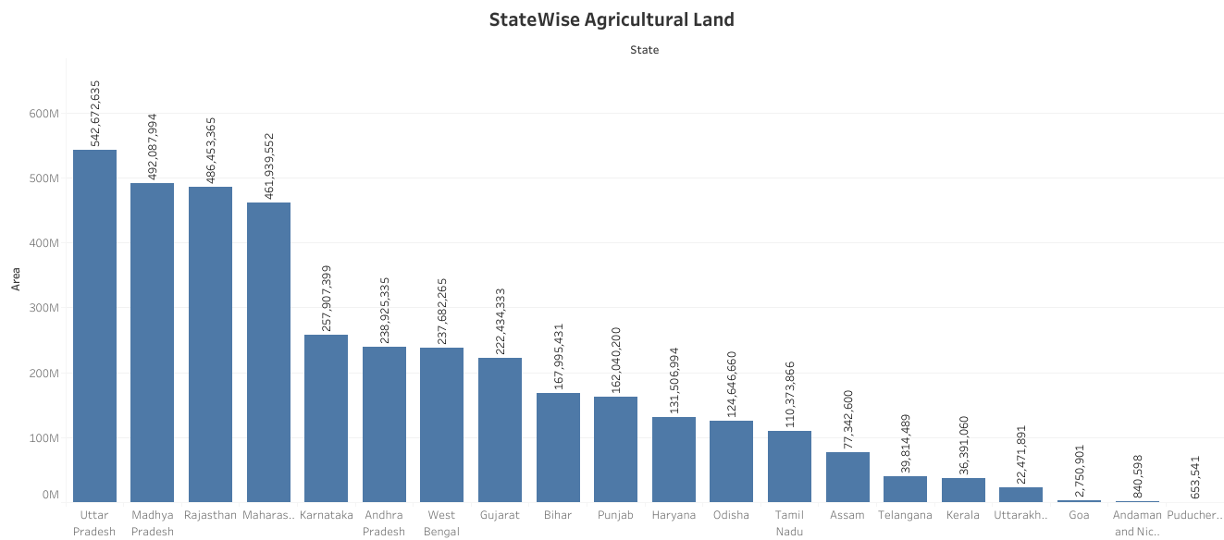

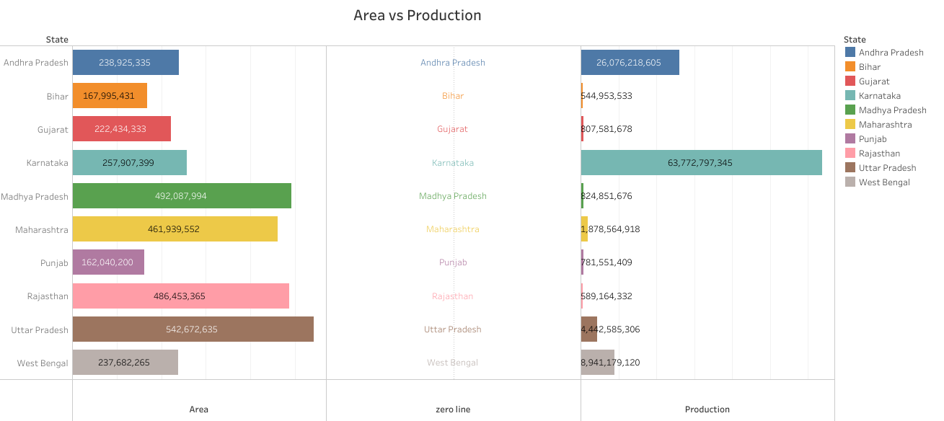

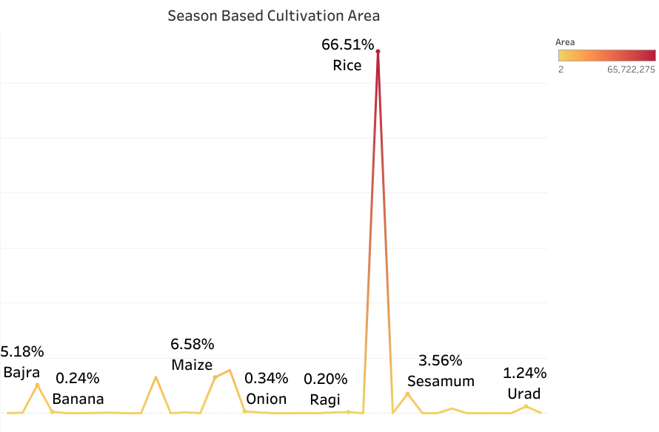

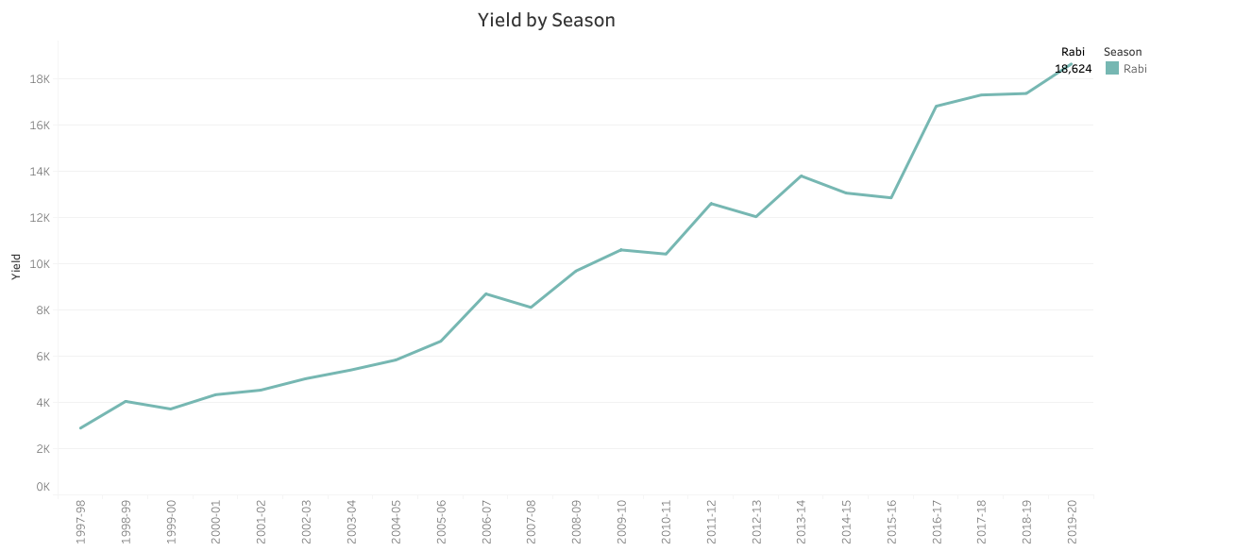

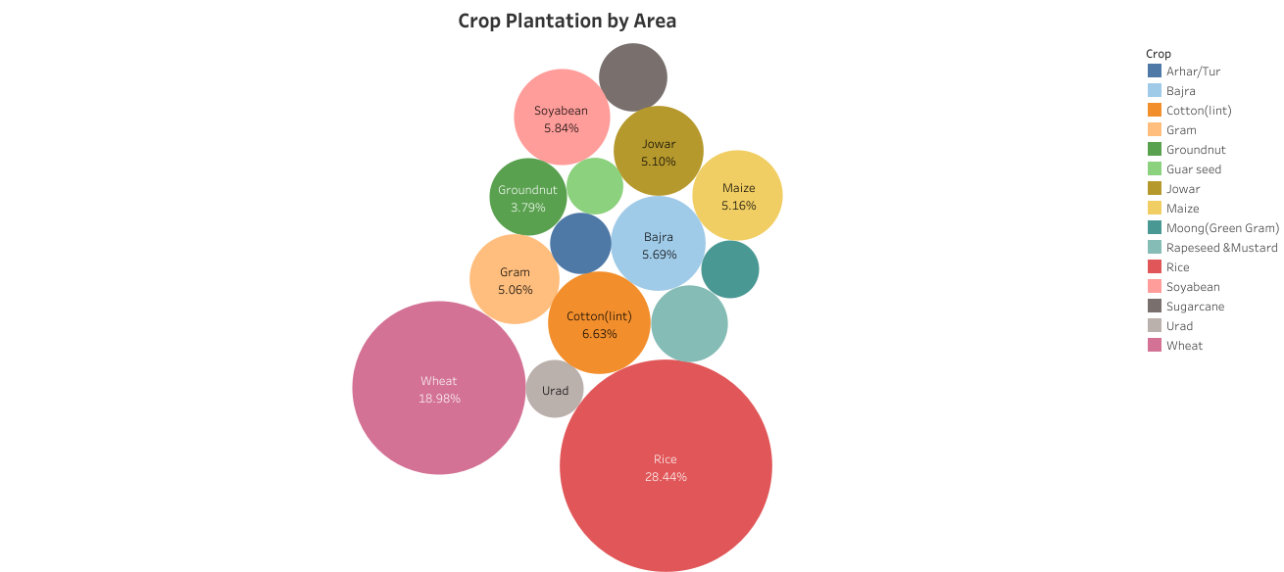

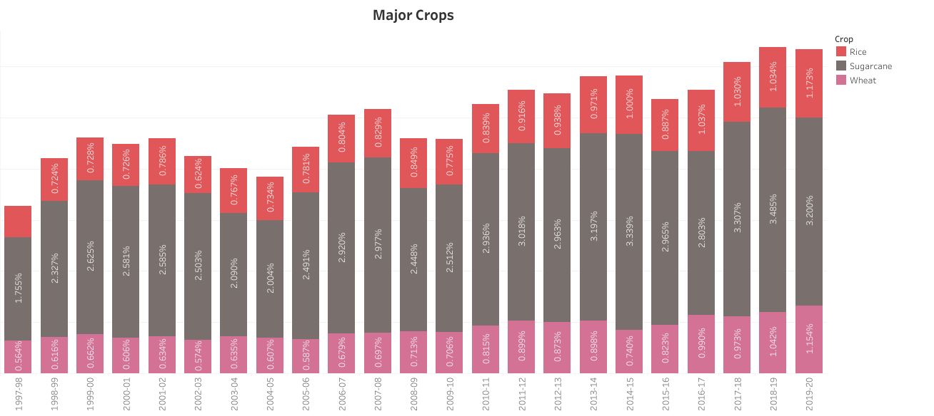

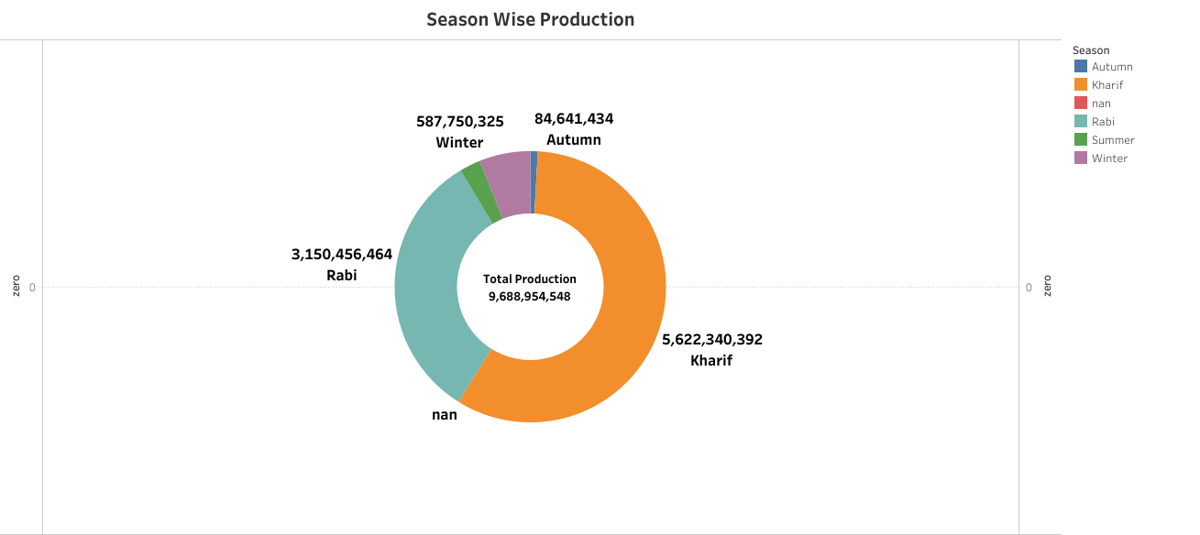

PROJECT RESULT

Dashboard and story can be used to track key performance indicators, monitor performance metrics, and display data in the form of charts, graphs, and tables

ADVANTAGES:

* Higher crop productivity
* Decreased use of water quantity, fertilizer, and pesticides, which in turn keeps food prices down
* Reduced impact on natural ecosystems
* Less runoff of chemicals into rivers and also groundwater
* Increased worker safety

DISADVANTAGES:

* Uncertainty in the water supply
* Lack of remunerative income
* Fragmentation of land holdings
* Lack of access to formal credit and also insurance
* Allied infrastructure (market access and storage facilities)